# Pizza Sales Using SQL and Excel

# Objective

This project aims to perform a detailed analysis of pizza sales data using SQL queries and visualize key business insights using Excel dashboards. The goal is to understand customer behavior, product performance, and time-based trends to improve business decision-making.

# Business Requirements & Problem Statement

The pizza restaurant wants to understand:  
- How much revenue they’re generating  
- What are the most and least popular pizzas  
- When customers are placing orders  
- Which pizza categories and sizes are performing best

**KPIs Calculated:**

1. Total Revenue: Sum of the total price of all pizza orders

2. Average Order Value: Total revenue ÷ total number of orders

3. Total Pizzas Sold: Sum of all pizza quantities

4. Total Orders: Count of unique orders placed

5. Average Pizzas Per Order: Total pizzas sold ÷ total orders

# SQL Queries Used

1. Total revenue:

SELECT sum(total_price) as Total_Revenue from pizza_sales;

1. Average order value:

SELECT sum(total_price)/count(distinct order_id) as Avg_Order_Value from pizza_sales;

1. Total Pizzas sold:

SELECT sum(quantity) as Total_Pizza_Sold from pizza_sales;

1. Total orders placed:

SELECT count(distinct(order_id)) as Total_Orders from pizza_sales;

1. Average pizzas per order:

SELECT CAST(CAST(sum(quantity) AS DECIMAL(10,2))/CAST(count(distinct order_id) AS DECIMAL(10,2)) AS DECIMAL(10,2)) as Avg_Pizza_Sold from pizza_sales;

Daily trend for total orders:

SELECT DATENAME(DW, order_date) as order_day, COUNT(DISTINCT order_id) as Total_Orders from pizza_sales

group by DATENAME(DW, order_date);

Hourly trend for orders:

SELECT DATEPART(hour,order_time)as order_hours, count(distinct order_id) as Total_Orders from pizza_sales

group by DATEPART(hour,order_time)

order by DATEPART(hour,order_time);

Percentage of sales by pizza category :

SELECT pizza_category, sum(total_price)as total_sales , sum(total_price)* 100/ (SELECT sum(total_price) from pizza_sales where MONTH(order_date)=1 )

as PCT from pizza_sales

where MONTH(order_date)=1

GROUP BY pizza_category;

Percentage of sales by pizza size :

SELECT pizza_size, cast(sum(total_price)as decimal(10,2)) as total_sales , cast(sum(total_price)* 100/ (SELECT sum(total_price) from pizza_sales where DATEPART(quarter,order_date)=1 )as decimal(10,2))

as PCT from pizza_sales

where DATEPART(quarter,order_date)=1

GROUP BY pizza_size

order by PCT desc;

Total no. of pizzas sold by pizza category:

SELECT pizza_category, sum(quantity)as Total_Pizza_Sold

from pizza_sales

group by pizza_category;

Top 5 best sellers by total pizzas sold:

SELECT top 5 pizza_name, sum(quantity) as Total_Pizzaa_Sold

from pizza_sales

group by pizza_name

order by sum(quantity) desc;

Bottom 5 best sellers by Total pizzas sold:

SELECT top 5 pizza_name, sum(quantity) as Total_Pizzaa_Sold

from pizza_sales

group by pizza_name

order by sum(quantity);

# Visualizations and Charts Created

* Daily Order Trend: Bar chart showing total orders by day of week
* Hourly Order Trend: Line chart showing total orders by hour
* Sales by Pizza Category: Pie chart showing revenue contribution per category
* Sales by Pizza Size: Pie chart showing revenue per size
* Pizzas Sold by Category: Funnel chart for quantity sold in each category
* Top 5 Pizzas Sold: Bar chart for best-selling pizzas
* Bottom 5 Pizzas Sold: Bar chart for least-selling pizzas

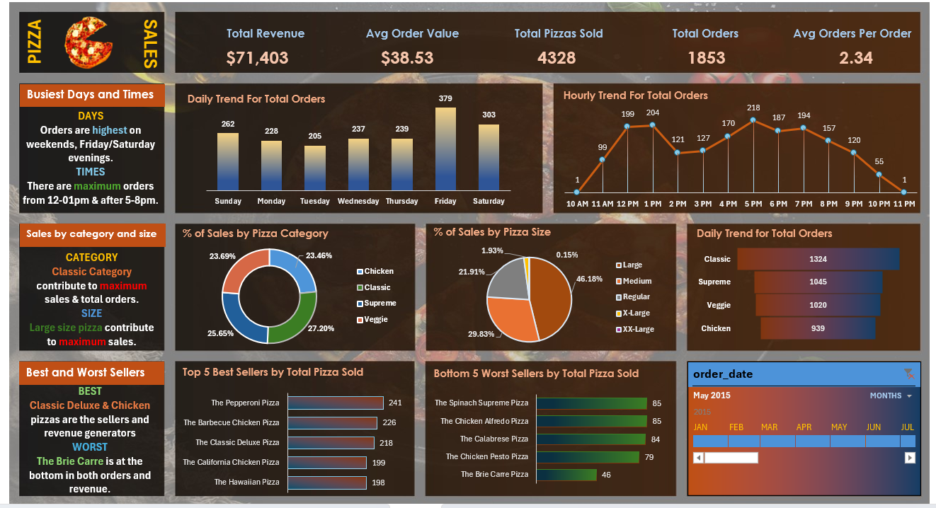

# Tools & Technologies Used

* SQL: Data cleaning and aggregation
* Excel: Creating interactive dashboard
* MS Word: Query documentation

# Insights and Observations

**Overall Performance Snapshot:**

* **Total Revenue:** $71,403
* **Average Order Value:** $38.53
* **Total Pizzas Sold:** 4,328
* **Total Orders:** 1,853
* **Average Pizzas Per Order:** 2.34
* **Busiest Days and Times:**

Orders are consistently highest on **Fridays and Saturdays**, indicating peak demand during the weekend.

* + The most active ordering times are between **12:00 PM - 1:00 PM** and **5:00 PM - 8:00 PM**, highlighting lunchtime and dinner rush periods. This information is crucial for staffing and operational planning.
* **Sales by Category and Size:**
  + The **"Classic" pizza category** contributes the most significantly to both sales and total orders.
  + **Large-size pizzas** account for the largest share of overall sales revenue, suggesting a customer preference for larger portions or potentially higher pricing for this size.
* **Best and Worst Selling Pizzas (Based on Revenue):**
  + **"Classic Deluxe" and "Chicken" pizzas** are the top revenue generators, indicating their popularity and potential higher price points or order frequency.
  + **"The Brie Carre"** is identified as the worst performer in terms of both orders and revenue, suggesting it may be unpopular or priced inappropriately.
* **Top 5 Best Sellers by Total Pizza Sold (Quantity):**

The top 5 most popular pizza choices based on the number of units sold are:

* + 1. The Pepperoni Pizza
    2. The Barbecue Chicken Pizza
    3. The Classic Deluxe Pizza
    4. The California Chicken Pizza
    5. The Hawaiian Pizza
* **Bottom 5 Worst Sellers by Total Pizza Sold (Quantity):**
  + The 5 least popular pizza choices based on the number of units sold are:
    1. The Brie Carre Pizza
    2. The Chicken Pesto Pizza
    3. The Calabrese Pizza
    4. The Chicken Alfredo Pizza
    5. The Spinach Supreme Pizza

**Observations:**

* There's a clear correlation between some of the best-selling pizzas by quantity and the top revenue generators (e.g., Classic Deluxe and Chicken).
* The "Brie Carre" consistently underperforms across both revenue and quantity sold, indicating a potential need for menu review or promotional efforts.
* Customer ordering behavior shows a strong preference for weekends and specific meal times.
* The "Classic" pizza category and "Large" size pizzas are significant drivers of overall sales.

Name: Khushi Papola  
MBA in AI & DS